Industry Awards

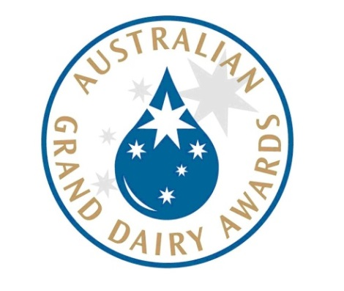
2004 Vogue Entertaining & Travel Magazine Australia
Featured in ‘Australia’s Best Gelato’
2005 Royal Melbourne Dairy Produce Awards
Tiramisu (Silver)
Cinnamon and Ginger (Silver)
2006 Royal Melbourne Dairy Produce Awards
Organic Cinnamon Donut (Gold)
Lemon Cheese Cake (Silver)
Pistachio Heaven (Silver)
2006 The Foodies Guide Five Best Gelato in Victoria
Fritz Gelato Low GI Chocolate
2007 Leader Business Awards, Stonnington
Winner - Convenience Food Retailer, Fritz Gelato Prahran Market
2007 Dairy Industry Association of Australia, Victorian Dairy Products Competition
Coffee Rush (Silver)
Very Vanilla (Silver)
Caramelised Fig & Roasted Almond (Silver)
Mint Choc Chip (Silver)
2007 Dairy Industry Association of Australia, Australian Dairy Products Awards
Coffee Rush (Silver)
Very Vanilla (Silver)
Caramelised Fig & Roasted Almond (Silver)
Mint Choc Chip (Silver)
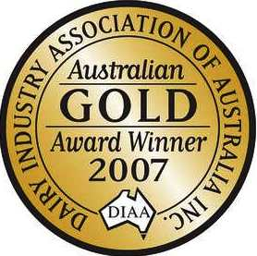
2007 The Foodies Guide Five Best Gelato in Victoria
Fritz Gelato Caramelised Fig & Roasted Almond
2007 Royal Melbourne Dairy Produce Awards
Old Fashioned Liquorice (Gold)
Plum Pudding (Silver)
Black Forest (Silver)
Rum & Raisin (Silver)
Pannacotta & Raspberry (Silver)
2008 Leader Business Awards, Melbourne
Winner - Convenience Food Retailer, Fritz Gelato Richmond
2008 Leader Business Awards, Stonnington
Winner - Convenience Food Retailer, Fritz Gelato Prahran Market
2008 Leader Business Awards, Port Phillip
Winner - Convenience Food Retailer, Fritz Gelato St. Kilda
2008 Dairy Industry Association of Australia, Victorian Dairy Products Competition
Chocolate Indulgence (Gold)
Organic Cinnamon & Ginger (Silver)
White Chocolate & Wasabi (Silver)
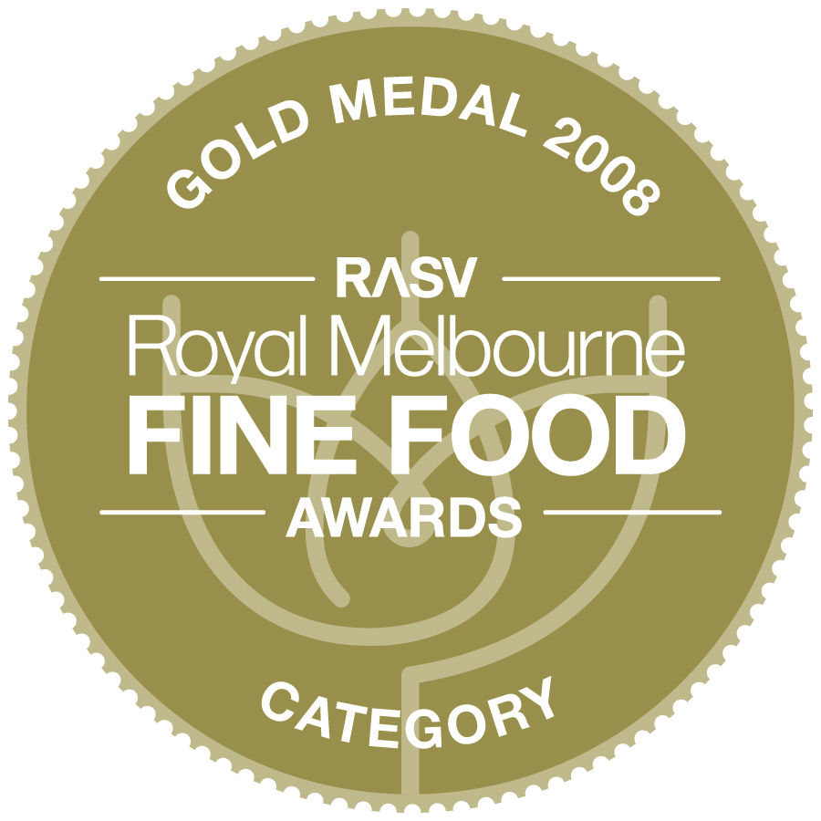
2008 Dairy Industry Association of Australia, Australian Dairy Products Competition
Chocolate Indulgence (Gold)
Organic Cinnamon & Ginger (Silver)
White Chocolate & Wasabi (Silver)
2008 Royal Melbourne Fine Foods Awards - Dairy Produce
Pistachio Heaven (Gold)
Baci Kisses (Gold)
Honeycomb (Silver)
White Chocolate & Toasted Macadamia (Silver)
2008 The Foodies Guide Five Best Gelato in Victoria
Fritz Gelato featuring Plum Pudding Ice-Cream.
2009 Dairy Industry Association of Australia, Australian Dairy Products Competition
Caramelised Fig & Roasted Almond (Gold)
White Chocolate & Toasted Macadamia (Silver)
Rum & Raisin (Silver)
2009 Royal Melbourne Fine Foods Awards - Dairy Produce
Pannacotta & Raspberry (Gold)
Chocolate Indulgence (Silver)
2009 The Foodies Guide Five Best Gelato in Victoria
Fritz Gelato featuring Raspberry Rumble sorbet and Tiramisu Ice-Cream
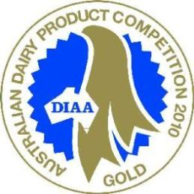
2010 Dairy Industry Association of Australia, Australian Dairy Products Competition
Hazelnut (Gold & NAB Agribusiness Award - Highest Scoring Gelati - Overall)
Baileys (Gold)
Spekulatius (Gold)
Low Fat Natural Yoghurt (Silver)
Almond Nougat (Silver)

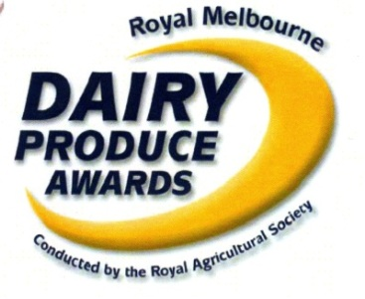
2010 Royal Melbourne Fine Foods Awards - Dairy Produce
Pistachio (Gold)
Cinnamon & Ginger (Silver)
Coffee Rush (Silver)
Pannacotta & Raspberry (Silver)
2010 The Foodies Guide Five Best Gelato in Victoria
Fritz Gelato featuring Blood Orange sorbet, Anzac Biscuit and Cinnamon & Ginger Ice Cream
2011 Dairy Industry Association of Australia, Australian Dairy Products Competition
Plum Pudding (Gold & NAB Agribusiness Award - Highest Scoring Gelati - Overall)
Green Tea (Silver)
Organic Natural Yoghurt (Silver)
2011 Royal Melbourne Fine Foods Awards - Dairy Produce
Baci Kisses (Gold and Overall Champion Gelato)
Chocolate Indulgence (Gold)
Cinnamon & Ginger (Silver)
Raspberry Rumble Sorbet (Silver)
2011 The Foodies Guide Five Best Gelato in Victoria
Fritz Gelato featuring Baci Kisses and Roasted Pumpkin Ice-Cream
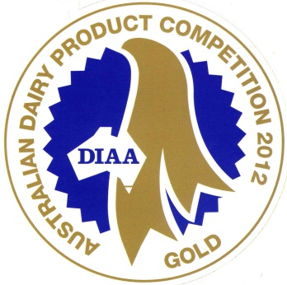
2012 Dairy Industry Association of Australia, Australian Dairy Products Competition
Chilli Chocolate (Gold)
Choc Orange (Gold)
Salted Caramel (Silver)
White Chocolate & Raspberries (Silver)
Pecan & Maple (Silver)
2012 Royal Melbourne Fine Foods Awards –
Dairy Produce & Sorbet Awards
Salted Caramel (Gold)
Roasted Pistachio & Walnut Baklava (Gold)
Passionfruit Kick (Gold)

2013 Dairy Industry Association of Australia, Australian Dairy Products Competition
Coffee Rush (Gold and Overall Champion Gelato)
Chocolate Indulgence (Silver)
Ol’Jamiacan Chocolate (Silver)
Stracciatella (Silver)
Strawberry Yoghurt (Silver)
2013 Royal Melbourne Fine Foods Awards - Dairy Produce & Sorbet Awards
Mocha Latte (Gold)
Go Bananas! (Gold)
Toasted Macadamia & Caramel (Silver)
Zesty Lemon (Silver)
Mango Tango (Silver)
*2014 Dairy Industry Association of Australia, Australian Dairy Products Competition
Lemon & Ricotta (Silver)
Raspberry Sorbet (Silver)

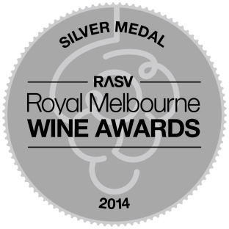
2014 Royal Melbourne Fine Foods Awards - Dairy Produce & Sorbet Awards
Toasted Macadamia & Maple Syrup (Silver)
Pistachio Heaven (Silver)
Sicilian Mandarin (Silver)
Apple & Raspberry (Silver)
Green Apple (Silver)

*2015 Dairy Industry Association of Australia, Australian Dairy Products Competition
Cinnamon & Ginger (Silver)
Salted Caramel (Silver)
Rum & Raisin (Silver)
Chili Chocolate (Silver)
Pistachio & Saffron (Silver)

2015 Royal Melbourne Fine Foods Awards - Dairy Produce & Sorbet Awards
Raspberry Rumble (Silver)
Hazelnut (Silver)
Coffee Rush (Silver)
Baci Kisses (Silver)

*2016 Dairy Industry Association of Australia, Australian Dairy Products Competition
Summer Cassata (Silver)
Apple Pie (Silver)
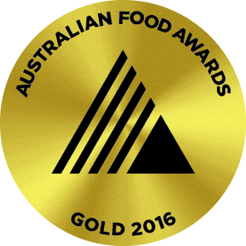
Chocolate Malt (Silver)
Toblerone (Silver)
After Dinner Mint (Silver)

2016 Australian Fine Foods Awards –
Dairy Produce & Sorbet Awards
Sour Cherry & Pomegranate Sorbet (Gold)
Poached Pear (Gold)
Vanilla Passionfruit (Gold)
Mocha Crackle Crunch with Hazelnut & Black Sesame (Bronze)

